Multiple-choice section – choose the correct answer

Question 1 [5.1]

The linear equation  has the solution:

A -4 B  C  D 4

Question 2 [5.2]

There are 20 students in a Year 9 Maths class. The number of boys is one-third of the number of girls in the class. An equation that correctly describes this situation is:

A 3*x* + *x* = 60 B *x* + = 20 C 3*x* + *x* = 20 D *x* + *x* = 40

Question 3 [5.3]

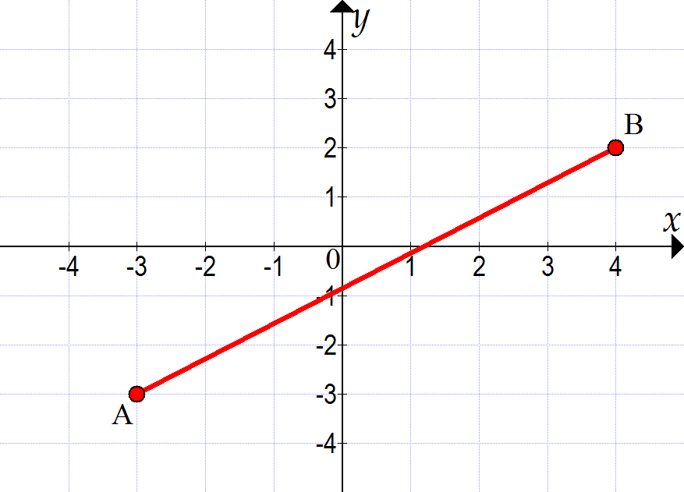

The length of the line segment *AB* above is:

A  B  C  D 

Question 4 [5.4]

The following table of values represents a linear relationship.

|  |  |  |  |  |
| --- | --- | --- | --- | --- |
| *a* | 0 | 2 | 4 | 6 |
| *b* | 5 | -1 | -7 | -13 |

The equation that represents this linear relationship is:

A *a* = -3*b* + 5 B *a* = 5*b* − 3 C *b* = 5*a* − 3 D *b* = -3*a* + 5

Question 5 [5.5]

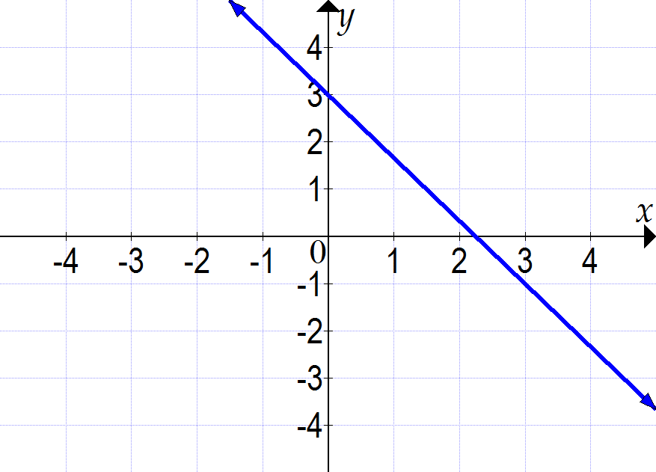

The gradient of the line shown above is:

A  B  C  D 

Question 6 [5.6]

The gradient of the line perpendicular to the line passing through (-2, -3) and (6, 4) is:

A  B  C  D 

Question 7 [5.7]

The coordinates of the *x*- and *y*-intercepts of the line 2*x* − 3*y* = 12 are, respectively:

A (6, 0) and (0, -4) B (0, -4) and (6, 0) C (4, 0) and (0, -6) D (0, 4) and (6, 0)

Question 8 [5.8]

Two straight lines are shown on the following graph.

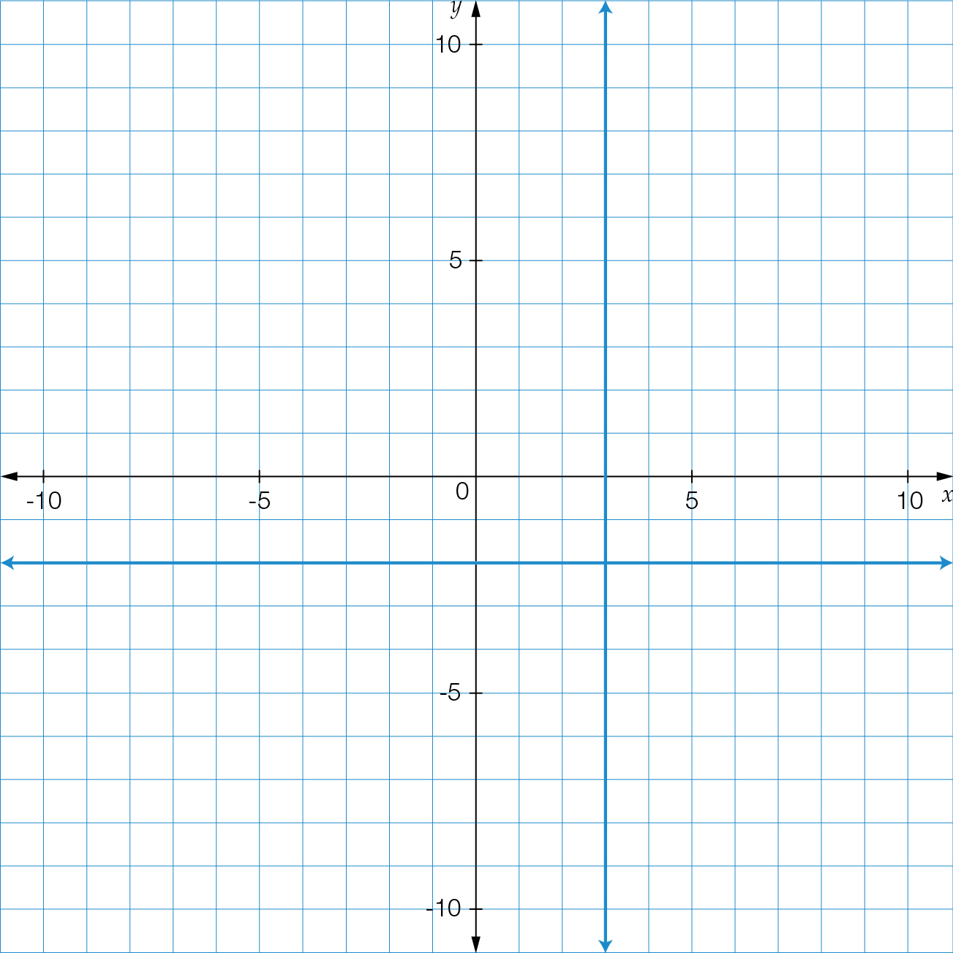

Which of the following alternatives is *not* true?

**A** One of the lines has an undefined gradient.

**B** One of the lines has zero gradient.

**C** *x* = 3 and *y* = -2

**D** *x* = -3 and *y* = 2

Multiple-choice results: ___ / 8

Short answer section

Question 9 3 marks [5.1]

Solve the linear equation .

Question 10 3 marks [5.2]

Greg is three times David’s age. How old are Greg and David now if, in 10 years’ time, the sum of their ages will be 72?

Question 11 5 marks [5.3]

A triangle has vertices at *A*(2, 7), *B*(6, 4) and *C*(2, 4).

**(a)** Find the length of each side.

**(b)** What type of triangle is it?

**(c)** Find the midpoint of the longest side.

Question 12 4 marks [5.4]

For the equation :

(a) complete the table of values

|  |  |  |  |  |  |
| --- | --- | --- | --- | --- | --- |
| T | -2 | -1 | 0 | 1 | 2 |
| P |  |  |  |  |  |

(b) plot the graph on the axes provided.

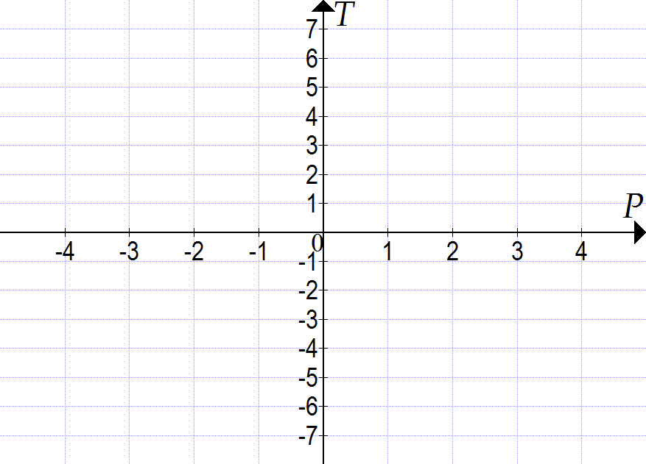

Question 13 4 marks [5.5]

Consider the following line segments:

*a*: (2, 1), (-2, -2)

*b*: (-2, 0), (1, -4)

*c*: (-1, 1), (2, -2)

*d*: (-1, 1), (-2, -3)

(a) Which line segment has the greatest *positive* gradient? What is this gradient?

(b) Which line segment has the greatest *negative* gradient? What is this gradient?

Question 14 3 marks [5.6]

Use the *y*-intercept and gradient method to sketch the graph of  on the axes provided.

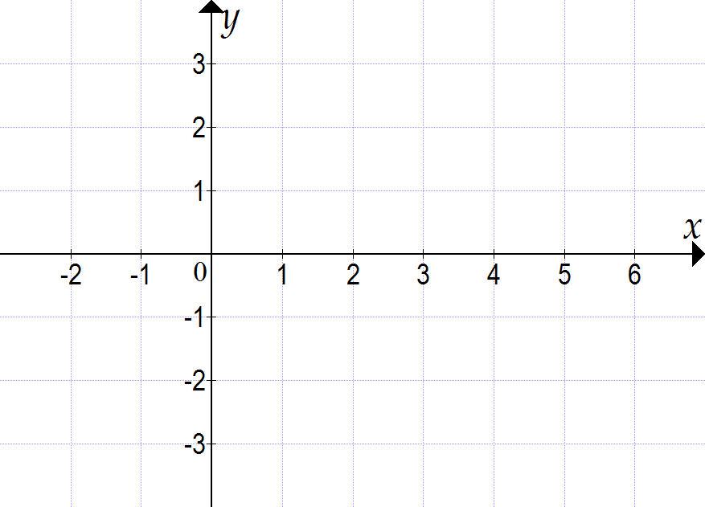

Question 15 3 marks [5.7]

Calculate the *x*- and *y*-intercepts of the equation 4*x* − 3*y* − 12 = 0, and use them to sketch the line on the number plane below. Clearly show the coordinates of the axis intercepts.

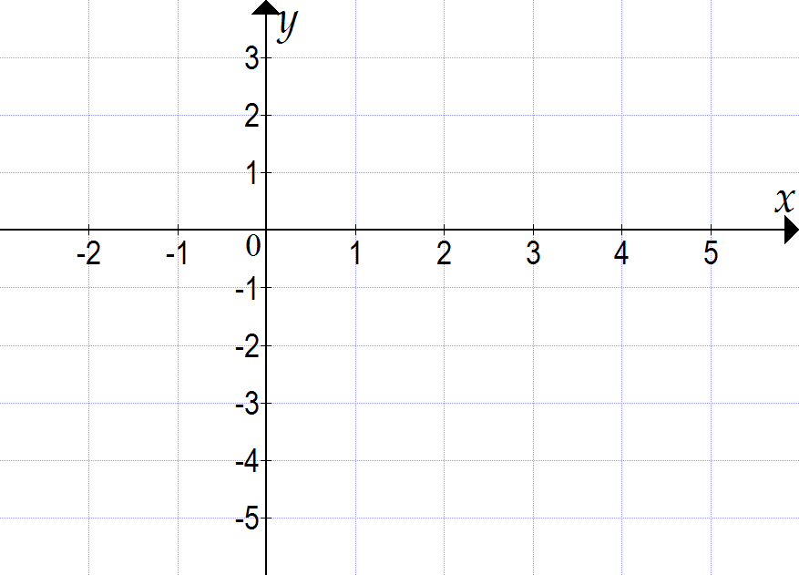

Question 16 2 marks [5.8]

Use the given information to write the equations of the following straight lines. Sketch the two lines on the number plane below.

**(a)** *m* = 0 and *c* = 2

**(b)** *x*-intercept = -3, gradient is undefined

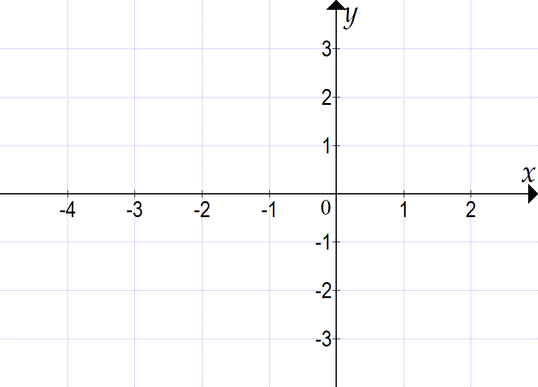

Short answer results: ___ / 27

Extended answer section

Question 17 5 marks [5.4, 5.5, 5.6, 5.7]

Explain how you can draw the graph of the equation *y* = 2*x* + 3 without drawing a table of values.

Question 18 10 marks [5.2, 5.3]

A quadrilateral *ABCD* has vertices at *A*(1, 9), *B*(4, 4), *C*(9, 1) and *D*(6, 6).

(a) Find the length of each side (you may use the grid provided to help you).

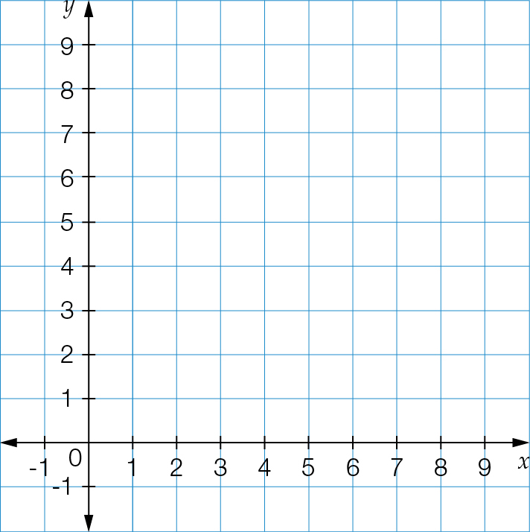

(b) Find the length of each diagonal.

(c) Looking at the lengths of the sides and diagonals, what type of quadrilateral is it?

(d) Find the midpoint of each diagonal.

(e) What do you notice about the midpoints of the diagonals?

Question 19 10 marks [5.2, 5.4, 5.5]

Axel, Brandon and Clarissa are taking part in a reading challenge fundraising event. They are seeking people to sponsor their reading efforts. Axel is asking for $1.50 for each book he reads. Brandon is asking for $3 plus $1 for each book he reads. Clarissa just asks for a flat $10 donation.

(a) Complete the following table of values for the three readers.

|  |  |  |  |  |  |  |  |  |  |
| --- | --- | --- | --- | --- | --- | --- | --- | --- | --- |
| Number of books/reader | 0 | 1 | 2 | 3 | 4 | 5 | 6 | 7 | 8 |
| Axel |  |  |  |  |  |  |  |  |  |
| Brandon |  |  |  |  |  |  |  |  |  |
| Clarissa |  |  |  |  |  |  |  |  |  |

(b) Use your table of values to plot a graph for each person. Label each graph with the person’s name.

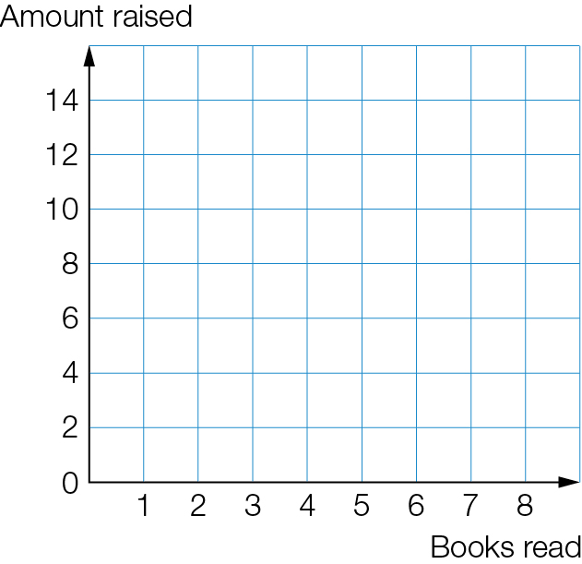

**(c)** Is there a number of books for which all collect the same amount of money? If so, what is it?

**(d)** Identify the number of books read for which:

**(i)** Axel raises the most money

**(ii)** Brandon raises the most money

**(iii)** Clarissa raises the most money.

Extended answer results: ___ / 25

TOTAL test results: ___ / 60